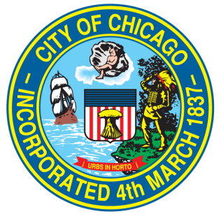
New Business Checklist
2nd Ward Alderman Brian Hopkins

The following checklist is designed to help prospective business owners create a new business plan or improve an existing business plan in preparation for a meeting with Alderman Hopkins and his staff.

Please return your completed business checklist or business plan to Ward02@cityofchicago.org.

BUSINESS CONCEPT
Business Name:
Business Address:

- What is the nature of your business? What products or services will you be selling?
- What is the name of the company that you plan to operate the business under? Does the company have a website?
- How many employees do you plan to hire?
- When do you plan to open?
- What are your expected hours for weekends? What are your expected hours for weekdays?
- Who is your landlord?
- Who is your attorney, if applicable?
- How many seats do you expect your business to have? (Or, what volume of customers is your business expected to hold?)
- If applicable, do you own any other businesses? If so, what are the names of those businesses?

PERMITTING AND LICENSING
- What licenses do you plan to apply for aside from a business license – food license, liquor license, etc?
- What hardships exist that you need to need to overcome – such as a zoning change, building renovations, lifting of a liquor moratorium – before the business can open?
- What sort of signage is planned for the location? Any other public right of way or grant of privilege applications that you anticipate (sidewalk cafe, awnings, decorative light fixtures, etc)?

LOGISTICS
- How do you plan to handle deliveries, and where will deliveries be made?
- What is the plan for parking?
- Will you be applying for a loading, standing, or valet zone? If so, for what hours?
- What security plan or measures do you intend to have in place – staffed security, cameras, alarms, etc?

